



**An HCD Learning Simulation Game**

Participants Manual

Table of Contents

**Overview**

**3**

What is eTales?

* Overview
* Your Mission and Roles
* Methodology

Business Scenario

* Market Situation
* Geography/Markets
* Categories
* Market Players
* Consumers as Shoppers

**Business Operation**

**7**

* Brief Overview

**Supplier Decisions**

**7**

* Portfolio Decisions
* Pricing Decisions
* Negotiation Agreements
* Production Volume Decisions
* General Marketing Decisions
* Online Store Management Decisions
* Asset Investment/R&D Decisions

**Retailer Decisions**

**13**

* Negotiation Agreements
* Marketing Decisions
* Private Label Portfolio Decisions
* Store Management Decisions

**Reports**

**16**

* General Reports
* Confidential Reports
* Market Research Reports

**Operational Aspects**

**20**

* Market Research Purchases
* Operating Budget
* Production Capacity
* Time Management

**Appendix**

**23**

**Overview**

What is eTales?

* **Overview**

eTales is a business simulation reflecting vividly the horizontal and vertical competition of Suppliers and Retailers in the consumer goods industry.

It mirrors the power dynamics in a competitive and changing market influenced by the modern communication channels, i.e. consumer empowerment through social media and its impact on power dynamics (brand communities), which results in channel migration and impacts Suppliers and Retailers profitability.

* **Your Mission and Role**

You and the other members of your team have just been recruited by a large supplier/retailer to replace the former management team to manage its business.

You will be seeking competitive advantage over your rivals in the industry. Administrator decides and announces what criteria are used to determine the winner. So your aim would be to develop and implement strategy and tactics allowing your team to get best scores and outplay your competition.

* **Methodology**

The simulation has 5 teams producing and selling two categories of products for two different markets. Three of the five teams represent suppliers and two teams represent modern bricks & mortar retail chains (retailers).

In addition, the simulation consists of two virtual entities – a supplier (for private labels), Traditional retailer (Mom & Pop stores). The suppliers can sell their products directly through eMall (a platform the suppliers use to run their online stores) or in-directly through retailers.

The diagram below shows the game structure:



The number of rounds to be played is decided by the administrator. Each round telescopes real 6-months period in the industry.

*Note!*

Initially, all teams will have access to the financial results of Period 0 and the market information of previous 3 periods. Then, they will be asked to make a set of decisions (i.e. decision 1) that will be processed by the administrator to generate the results of the subsequent period (i.e. period 1). The whole process will be repeated several times. After the last round, the final evaluations will be performed to determine which team achieved the best results.

Business Scenario

* **Market Situation**

The currency unit is $. The **inflation** itself remains relatively stable at around **8.5% on a yearly basis.**

**Market growth** is quite significant, with a rate approaching **9% in average on a yearly basis (around 2% per quarter)**. At the same time, the market is very price sensitive and any price increases significantly exceeding inflation may result in volume growth stabilization, or even reduction. The fast pace of consumers’ maturing is constantly forcing the suppliers to improve their offer and/or increase efficiency.

* **Geography/Markets**

There are two geographical markets: Rural and Urban. Below is an overview of these two markets:



Urban market is ahead of Rural market in terms of development. Urban is more stable, rural is more dynamic, prone to catch up urban. Both markets are dependent, that is:

* Brand awareness/preferences in Rural are affected by brand performance in Urban
* Store perception in Rural is affected by store performance in Urban.
* **Categories**

There are two product categories: Elecssories and HealthBeauties. Elecssories are small appliances, electrical accessories and supplies. HealthBeauties constitute health and beauty aids. Each company manages both categories. Suppliers do research, design, production, marketing and distribute products through Retailers, both online and brick&mortar.

Below is a comparison of the two product categories:



* **Market Players**

Three Supplier (Supplier 1, Supplier 2 and Supplier 3) and two Retailer (Retailer 1 and Retailer 2) teams compete in two markets: Urban and Rural. The suppliers can sell directly to consumers through the online platform or sell indirectly through retailers. Retailers only sell through their stores but sell supplier brands as well as their own private labels.

Virtual Supplier (Supplier 4) is played by the computer and serves primarily two purposes:

* It supplies Retailer 1 and Retailer 2 with their private labels
* If active suppliers fail to satisfy consumer demand with innovations, it may launch new innovative products distributed through eMall.

The Virtual Retailer 3 is a traditional retailer (Mom & Pop stores, convenience stores, etc.)

* **Consumers as Shoppers**

Retailer stores are perceived by shoppers/consumers in three dimensions:

1. Convenience
2. Assortment
3. Price Appeal

Shopping habits are only presented implicitly. The choice of store is determined by consumer segment preferences.



Shopper Segments are defined from channel preference standpoint and thus include:

1. Online Only
2. Bricks & Mortar Only
3. Mixed

**Business Operation**

Brief Overview

In each period, you’ll make a set of decisions. The decisions made vary depending on whether you are a supplier or a retailer. Following is the list of decisions:

**Supplier Decisions:**

* **Portfolio Decisions**
* **Pricing Decisions**
* **Negotiation Agreements**
* **Production Volume Decisions**
* **General Marketing Decisions**
* **Online Store Management Decisions**
* **Asset Investment/ R&D Decisions**

**Retailer Decisions:**

* **Negotiation Agreements**
* **Marketing Decisions**
* **Private Label Portfolio Decisions**
* **Store Management Decisions**

In order to make these decisions, you are provided information through the following reports:

* **General Reports**
* **Confidential Reports**
* **Market Research Reports**

**Supplier Decisions**

Portfolio Decisions

* Initially every supplier carries both categories, each category with 3 brands, in total 6 brands (8 SKU) at the starting point. Suppliers could carry maximum 5 brands in parallel for each category and each brand takes maximum 3 SKU.
* First letter in brand name determines the category, E represent Elecssories, H for HealthBeauties. The digit at the end points to supplier number, and SKU is labeled in the end. For example HOLAY1_A, refers to Supplier 1, HealthBeauties category, brand OLAY, with A as its SKU label.
* Brand names ending with "5" and "6" indicate private labels of Retailer1 and Retailer 2 respectively.
* You have to determine your product portfolio, i.e. brand names, SKU of each brand and product composition, including packaging format. There are three package options available: Economy, Standard, Premium which reflect the quality of the package.
* You may make a decision to:
* Change composition of an existing SKU

- To modify a variant’s specification, enter the desired spec value.

However, the Pack-Format cannot be changed. The changes are

highlighted in red.

* Start a new SKU of an existing brand

- To add a new variant under an existing brand, click on the brand name in

the table, and enter the variant name with specifications. The new

variant is highlighted in red.

* Launch a new brand

- To add a new brand/variant click on “Brand” button and enter the

brand/variant name with specifications. The new brand/variant is

highlighted in red.

* Discontinue a SKU or a brand altogether

- To discontinue an existing SKU, click on the SKU name. If you decide to

discontinue a product, you need to collect inventory from Retailers, then

scrap returns from trade as well as your own stock left at warehouse at

loss. Supplier needs to compensate retailers 75% of its purchase price.

* Please keep in mind that product composition affects both brand perception and product cost.

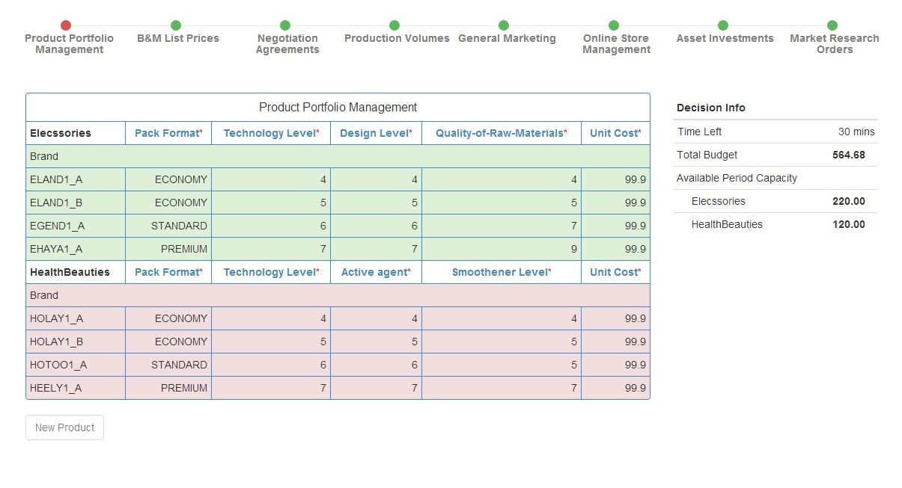

Pricing Decisions

* Supplier decides the B&M List prices for the SKUs in supplier’s product portfolio by category. The list prices from previous period are shown by default and the supplier can change it. All the changes are highlighted in red. If the decisions are not validated within the deadline, those from the previous period are entered with the old list prices adjusted for inflation.

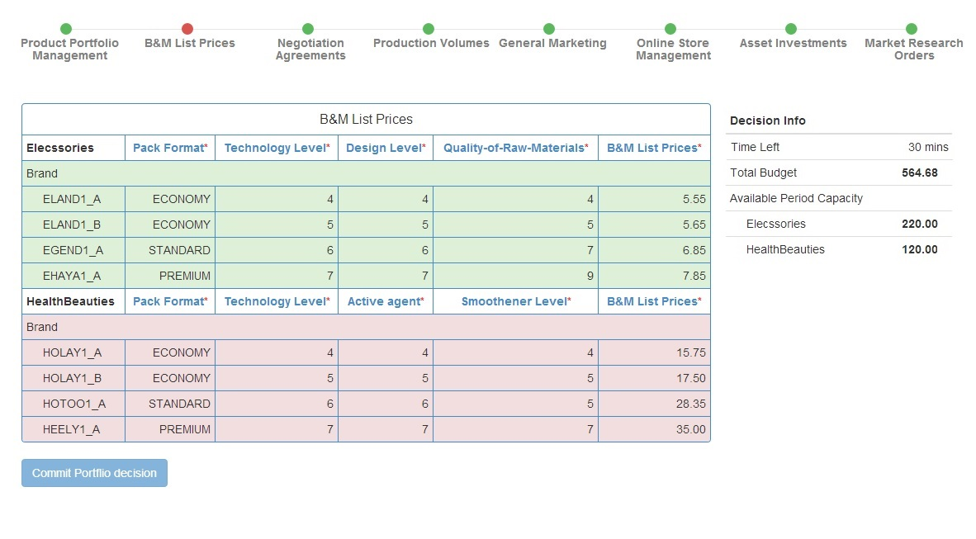

Negotiation Agreements

* Suppliers negotiate with each of the two retailers on the following items:

1. Discount rate for a Minimum Order Quantity
2. Bonus Rate for a target volume
3. Payment Terms (in terms of days) and Other compensation

* Negotiation is done at SKU level for each product category. When the negotiation round starts, the agreed-to contract terms from previous period are displayed. Thereafter, supplier or retailer can initiate proposals by changing the terms, which are highlighted in red (items proposed by supplier) and blue (items proposed by retailer). Once the contract terms are agreed for an SKU, either supplier or retailer or both can click on agree button. If both click on the agree button, the negotiation agreement for that SKU is frozen. Once all the SKU agreements are reached, each party clicks on “Validate Contract” button on the bottom of the screen. If both click it, the contract between both the parties is frozen.
* For the SKUs for which agreements are not reached before the deadline, the results from the previous period are displayed by default. Then, the Supplier and Retailer have an option to either agree to the contract from previous period or have no deal at all.

*Note!*

You can enter negative values in the Other Compensation if the other party pays for you for a service (e.g., purchase of market research reports).

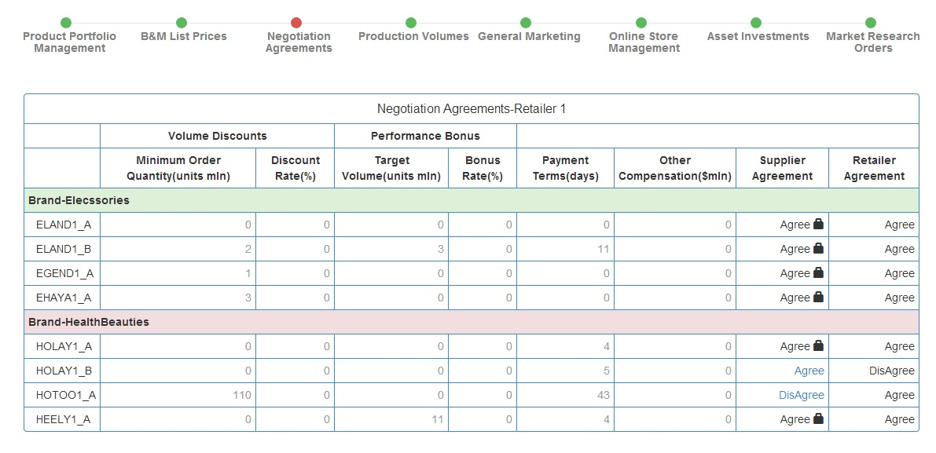

Production Volume Decisions

* Suppliers decide the production volume for each SKU in their product categories based on the negotiation agreements with the Retailers. The production volumes from previous period are shown by default and the supplier can change it. All the changes are highlighted in red. If the decisions are not validated within the deadline, those from the previous period are submitted.

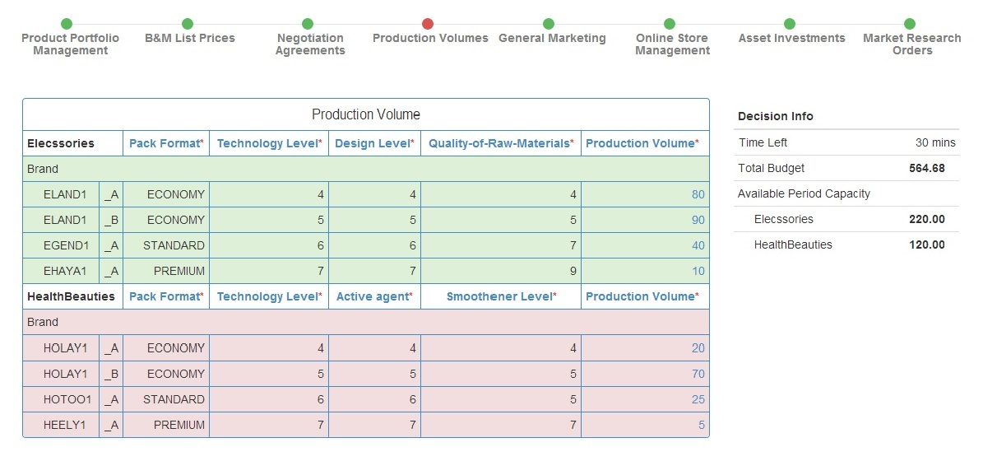

General Marketing Decisions

* General Marketing Decision comprises of two main areas of spending:

1. Advertising
2. Online (At national level)
3. Offline – Urban & Rural
4. Traditional Trade Support
5. Rural
6. Urban

* All the decisions are made at SKU level for each product category.
* The values from previous period are shown by default and the supplier can change it. All the changes are highlighted in red. If the decisions are not validated within the deadline, those from the previous period are submitted.

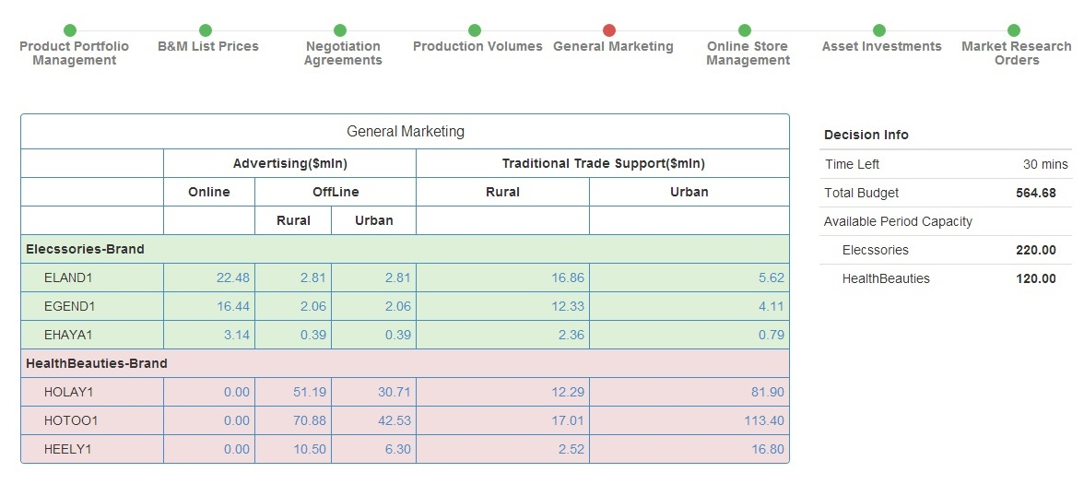

Online Store Management Decisions

* In this decision, Suppliers can decide how to manage their online strategy. In specific, the can decide how much to spend for:

1. Visibility
2. Order Volumes
3. Online Prices
4. And Promotions (in terms of days and depth)

* While Visibility is decided at Brand Level, rests of the values are decided at SKU Level.
* The values from previous period are shown by default and the supplier can change it. All the changes are highlighted in red. If the decisions are not validated within the deadline, those from the previous period are submitted.

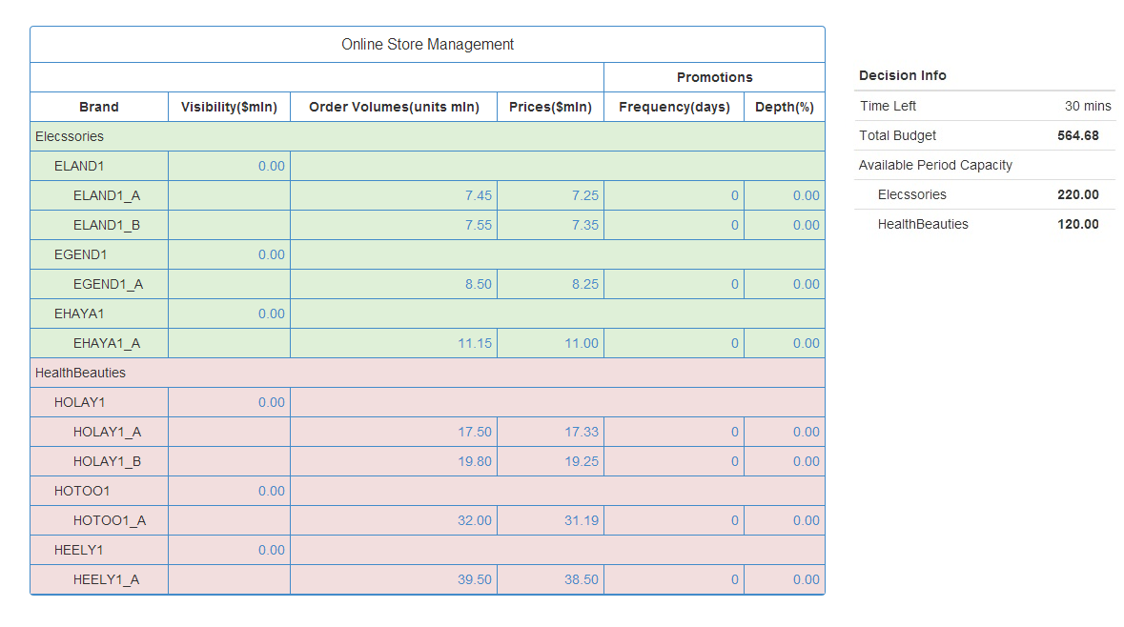

Asset Investments

* These decisions are long-term investments, not taken from your limited operational budget. You borrow these investments from capital market at a cost. Keep in mind that your long-term investments increase your fixed assets and consequently costs of running business. In specific, the can decide how much to spend for:

1. Capacity
2. Technology
3. Flexibility
4. Design

* The asset investment decisions are made for each product category.
* When the cursor hover over these items, a pop-up showing the feasible range of values appears. The values from previous period are shown by default and the supplier can change it. All the changes are highlighted in red. If the decisions are not validated by the deadline, those from the previous period are submitted.

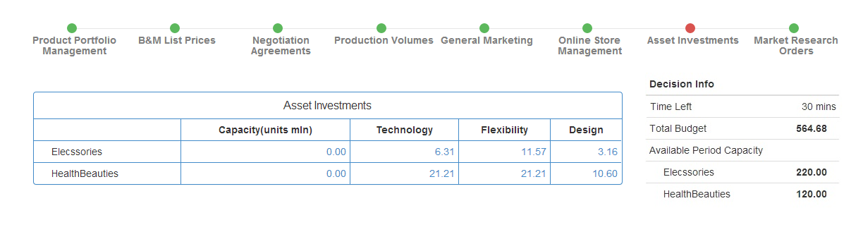

Market Research Decisions (purchase)

* Twelve market research studies are available for suppliers to make better informed decisions. They are not free and come with a price. Following is the list:

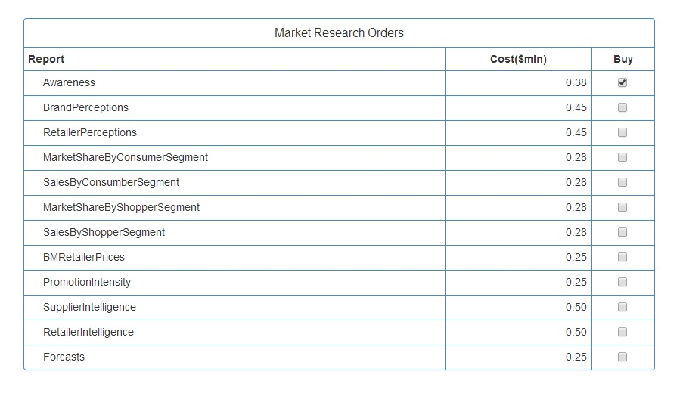

* Each study is conducted in each cycle and the results are made available at the end of the cycle of purchase.

**Retailer Decisions**

Negotiation Agreements

* Retailers negotiate with each of the three suppliers on the following items:

1. Discount rate for a Minimum Order Quantity
2. Bonus Rate for a target volume
3. Payment Terms (in terms of days) and Other compensation

* Negotiation is done at SKU level for each product category. When the negotiation round starts, the agreed-to contract terms from previous period are displayed. Thereafter, supplier or retailer can initiate proposals by changing the terms, which are highlighted in red (items proposed by supplier) and blue (items proposed by retailer). Once the contract terms are agreed for an SKU, either supplier or retailer or both can click on agree button. If both click on the agree button, the negotiation agreement for that SKU is frozen. Once all the SKU agreements are reached, each party clicks on “Validate Contract” button on the bottom of the screen. If both click it, the contract between both the parties is frozen.

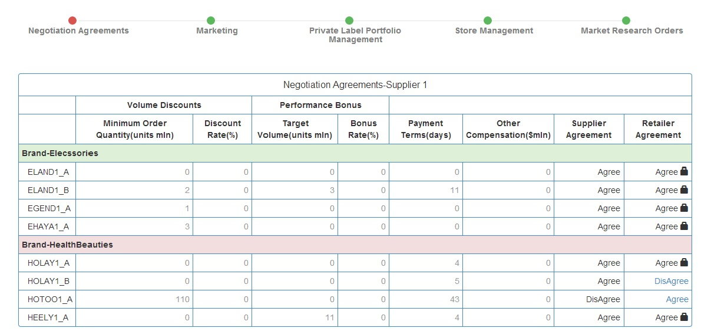

*Note!*

You can enter negative values in the Other Compensation if the other party pays for you for a service (e.g., purchase of market research reports).

Marketing Decisions

* For Retailers, marketing decisions mainly comprises of advertising spending and In-store service level. For the online advertising, spending is mainly decided between price and convenience. For local advertising, spending is decided for rural and urban markets.

1. Online Advertising
2. Price Appeal
3. Covenience
4. Local Advertising
5. Rural
6. Urban

* In store service level mainly has impact on how your customers perceive your stores. The spending is decided for rural and urban markets.
* The values from previous period are shown by default and the retailer can change it. All the changes are highlighted in red. If the decisions are not validated within the deadline, those from the previous period are submitted. The range of values for In-Store levels is displayed when cursor hovers over the “In-Store Service Level” label.

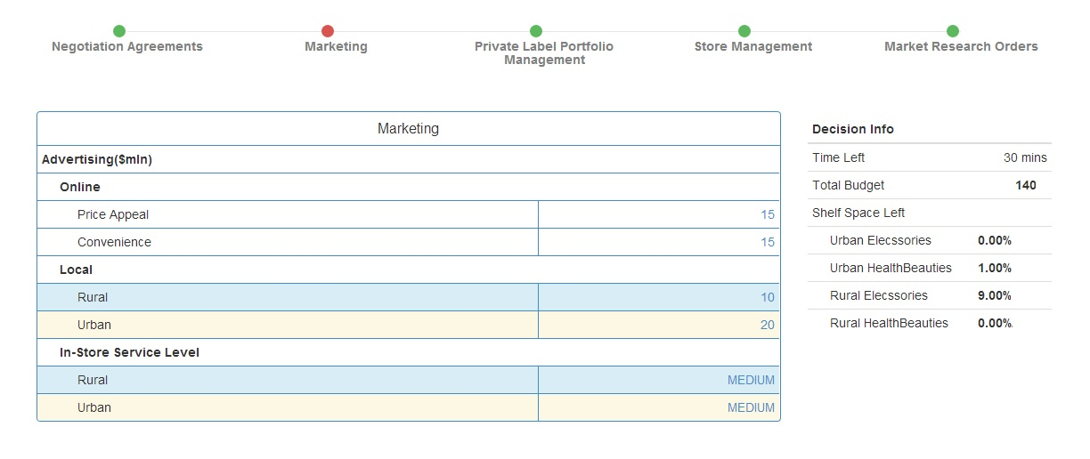

Private Label Portfolio Decisions

* Initially retailers start with one private label per category per market. At maximum, each retailer has three private labels per category per market.
* Private labels are produced by Supplier 4, which can deliver any product as long as the required volume does not exceed its production capacity and product composition is not beyond the acquired know-how of Supplier 4. (In general, Supplier 4 can’t deliver a product that is substantially more advanced than the existing ones).
* Brand names ending with "5" and "6" indicate private labels of Retailer1 and Retailer 2 respectively.
* You have to determine your product portfolio, i.e. brand names, SKU of each brand and product composition, including packaging format. There are three package options available: Economy, Standard, and Premium which reflect the quality of the package.
* You may make a decision to:
* Change composition of an existing SKU

- To modify a variant’s specification, enter the desired spec value.

However, the Pack-Format cannot be changed. The changes are

highlighted in red.

* Start a new SKU of an existing brand

- To add a new variant under an existing brand, click on the brand name in

the table, and enter the variant name with specifications. The new

variant is highlighted in red.

* Launch a new brand

- To add a new brand/variant click on “Brand” button and enter the

brand/variant name with specifications. The new brand/variant is

highlighted in red.

* Discontinue a SKU or a brand altogether

- To discontinue an existing SKU, click on the SKU name.

* Please keep in mind that product composition affects both brand perception and product cost.

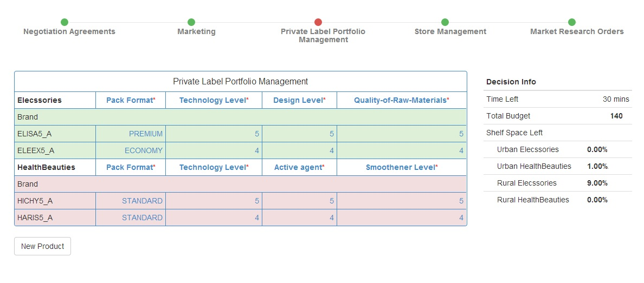

Store Management Decisions

* Store Management decisions are mainly to spending Order Volumes, Retail Prices and Shelf-Space Allocation, along with decisions for promotions.
* The decisions are taken at SKU Level per market per category. The sum of total shelf space for each market & category should be 100%.
* The values from previous period are shown by default and the retailer can change it. All the changes are highlighted in red. If the decisions are not validated within the deadline, those from the previous period are submitted.

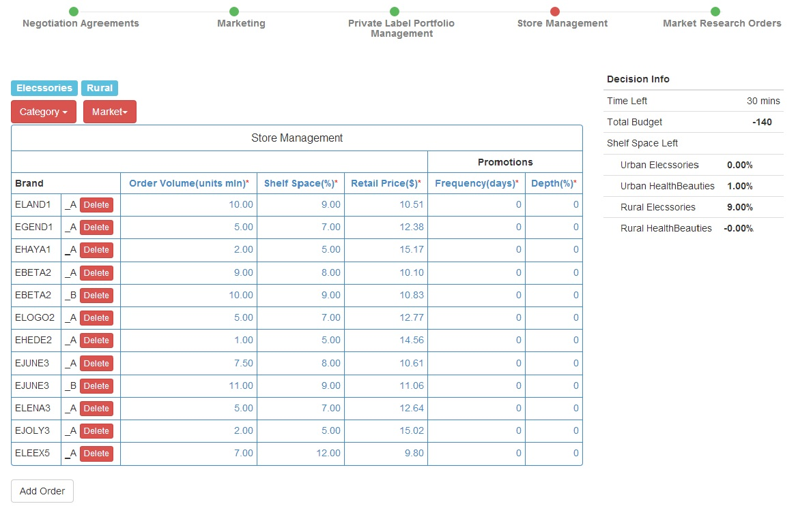

Market Research Purchases

* Twelve market research studies are available for retailers to make better informed decisions. They are not free and come with a price. Following is the list:



* Each study is conducted in each cycle and the results are made available at the end of the cycle of purchase.

**Reports**

General Report:

* The General Report is identical for all the players. It contains:
* **Performance Highlights**

The Performance Highlights report summarizes the key performance indicators for suppliers and retailers.

* **Market Shares**

The Market Shares report shows the consumer market shares for suppliers and retailers (private label) by market, consumer segments and shopper segments.

* **Sales**

The Sales report shows the consumer sales figures for suppliers and retailers (private label) by market, consumer segment and shopper segment.

* **Segment Leadership**

The Segment Leadership report shows the top two consumer share leaders by category, consumer segment and shopper segment.

* **Cross-Segment Sales Volume**

The Cross-Segment Sales Volume shows, by category and by market, the sales volume bought by each shopper segment.

* **Product Portfolio**

The Product Portfolio shows the technical design specifications of all SKUs in the market.

* **eMall Prices and Promotion Intensity**

This report shows the net online retail prices and promotion intensity.

Confidential Reports:

* Supplier/Retailer gets its own Confidential Report. It contains:

**For Suppliers:**

* **Financial Results**
  + - **Consolidated Profit & Loss Statement**

This report shows the consolidated Profit & Loss statement by category in each channel for the supplier

* + - **B&M Business Profit & Loss Statement**

This report shows the B&M business Profit & Loss statements of the supplier for both categories by brand.

* + - **Online Business Profit & Loss Statement**

This report shows the online business Profit & Loss statements of the supplier for both categories by brand

* + - **Profitability by Channel**

This report shows the profitability by category in each channel for the supplier.

* + - **Last Period Negotiations**

This report shows the negotiation agreements made by the supplier with the two retailers during the last period and whether or not these agreements were honored.

* + - **Market Research Purchases**

This report summarizes the list of market research studies purchased in the previous period.

* **Elecssories Situation Reports**
  + - **Market Shares by Consumer Segment**

This report shows the market shares of each SKU owned by the supplier by consumer segment for the Elecssories product category.

* + - **Market Shares by Shopper Segment**

This report shows the market shares of each SKU owned by the supplier by shopper segment for the Elecssories product category.

* + - **Volume**

This report shows the volume information for each SKU in the Elecssories category including the initial inventory, production cost, sales volume, discontinued goods volume and closing inventory.

* **HealthBeauties Situation Reports**
  + - **Market Shares by Consumer Segment**

This report shows the market shares of each SKU owned by the supplier by consumer segment for the HealthBeauties product category.

* + - **Market Shares by Shopper Segment**

This report shows the market shares of each SKU owned by the supplier by shopper segment for the Health Beauties product category.

* + - **Volume**

This report shows the volume information for each SKU in the HealthBeauties category including the initial inventory, production cost, sales volume, discontinued goods volume and closing inventory.

* **Key Performance Indicators**

This report shows the KPI’s of the supplier by category. The KPI’s include Effectiveness of Trade Spending, Effectiveness of Marketing Spending, Portfolio Strength and Channel Strength.

**For Retailers:**

* **Financial Results**

**Consolidated Profit & Loss Statement**

This report shows the consolidated Profit & Loss statement by category in each market for the retailer

* + - **Rural Profit & Loss Statement**

This report shows the Profit & Loss statements of the retailer for both categories by brand in the rural market.

* + - **Urban Profit & Loss Statement**

This report shows the Profit & Loss statements of the retailer for both categories by brand in the urban market

* + - **Profitability by Supplier**

This report shows the profitability of the retailer by category through each supplier.

* + - **Last Period Negotiations**

This report shows the negotiation agreements made by the retailer with the three suppliers during the last period and whether or not these agreements were honored.

* + - **Market Research Purchases**

This report summarizes the list of market research studies purchased in the previous period.

* **Rural Situation Reports**
  + - **Market Shares by Consumer Segment**

This report shows the market shares of each SKU by consumer segment for the Rural market.

* + - **Market Shares by Shopper Segment**

This report shows the market shares of each SKU by shopper segment for the Rural market.

* + - **Volume**

This report shows the volume information for each SKU in the Rural market including the initial inventory, ordered volume, sales volume, discontinued goods volume and closing inventory.

* **Urban Situation Reports**
  + - **Market Shares by Consumer Segment**

This report shows the market shares of each SKU by consumer segment for the Urban market.

* + - **Market Shares by Shopper Segment**

This report shows the market shares of each SKU by shopper segment for the Urban market.

* + - **Volume**

This report shows the volume information for each SKU in the Urban market including the initial inventory, ordered volume, sales volume, discontinued goods volume and closing inventory.

* **Key Performance Indicators**

This report shows the KPI’s of the retailer by market. The KPI’s include Rotation Index, Profitability Index, Stock Cover and Share of shoppers.

Market Research Reports:

* Following is the list of Market Research Reports available for Retailers and Suppliers. Suppliers and Retailers need to decide each period which studies they will purchase.
* **Awareness**

The Awareness report shows the levels of awareness for each brand in each market. The red section of the bar shows the drop in awareness over the last two periods; hence, the grey section is the level of awareness in the last period. The green section of the bar shows the increase in awareness over the last two periods; hence, the grey section plus the green section is the level of awareness in the last period.

* **Brand Perceptions**

The report shows the perceptual positions of the SKUs by category and market. The positions are color-coded by supplier and retailer (for private label SKUs).

* **Retailer Perceptions**

The report shows the perceptual positions of the retailers by market.

* **Market Shares by Consumer Segment**

The report depicts the volume and value market shares for the brands in Elecssories and HealthBeauties category by Consumer Segments. It has four sub reports one for the combination of each category and market.

* **Sales by Consumer Segment**

The report depicts the volume and value sales for the brands in Elecssories and HealthBeauties category by Consumer Segments. It has four sub reports one for the combination of each category and market.

* **Market Shares by Shopper Segment**

The report depicts the volume and value market shares for the brands in Elecssories and HealthBeauties category by Shopper Segments. It has four sub reports one for the combination of each category and market.

* **Sales by Shopper Segment**

The report depicts the volume and value sales for the brands in Elecssories and HealthBeauties category by Shopper Segments. It has four sub reports one for the combination of each category and market.

* **B&M Retail Prices**

The report shows the B&M Retail prices of all the SKU’s in both the product categories by all the retailers.

* **Promotion Intensity**

This report shows the promotion intensity of all the SKU’s in both the product categories by all the retailers.

* **Supplier Intelligence**

This report shows the spending on advertising, trade support, online investments and assets by all the suppliers by product category.

* **Retailer Intelligence**

This report shows the spending on advertising, along with the in store service level, and shelf space allocation of all the retailers by market.

* **Forecast**

This report shows the historical values and the two-period ahead forecasts of the consumer segment sizes and Shopper segment size, by category and market along with the category volumes and internet penetration rate by market.

**Operational Aspects**

Operating Budget

* The operating budget is limited and fixed for the length of the game.
* Profits earned will not be allocated to the operating budget.
* All the spending for suppliers and retailers will be financed from the operating budget. The detailed list is shown below.
* The exceptions are investments in assets which are amortized come out of capital budget.



* You can find your remaining operating budget using the budget calculator

Production Capacity

* Details of production capacity could be found in the capacity calculator imbedded in the production volume decision.

Time Management

* The time bar indicates how much time is left for each round before the deadline. There are three deadlines:



Good luck!

**Appendix**

General Reports:

1. Performance Highlights

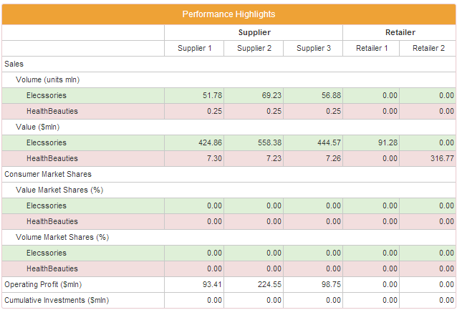

1. Market Shares

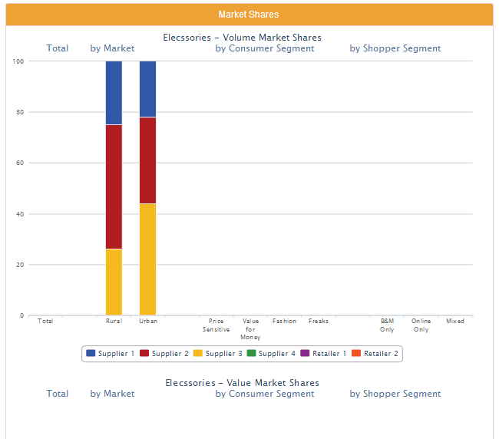

1. Sales

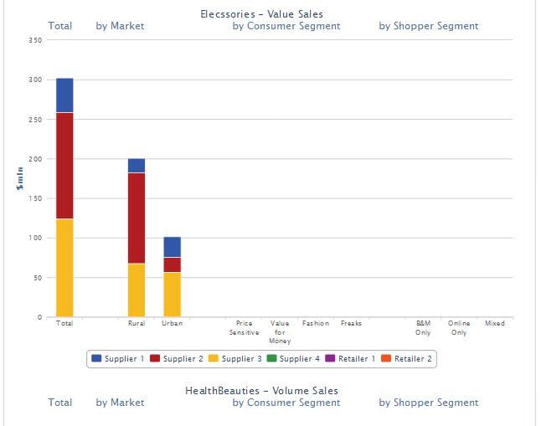

1. Segment Leadership

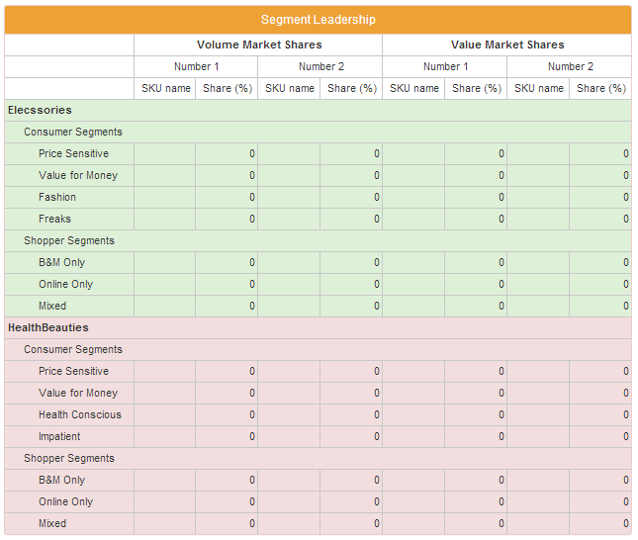

1. Cross Segment Sales Volume

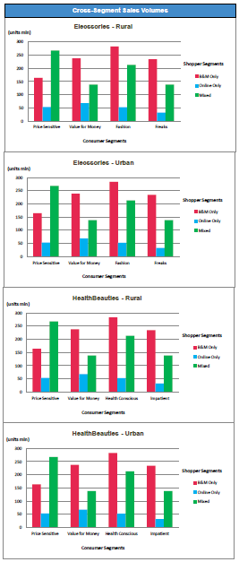

1. Product Portfolio

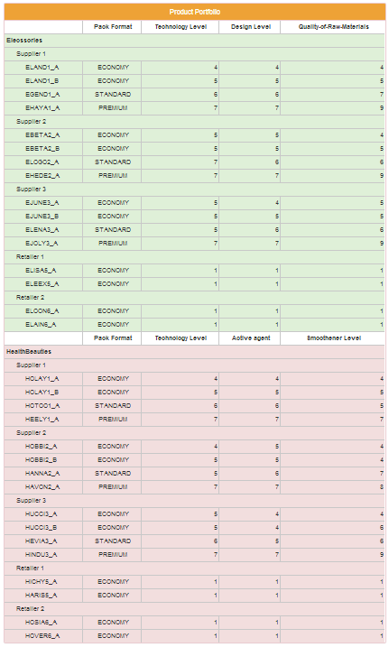

1. eMall Prices & Promotion Intensity

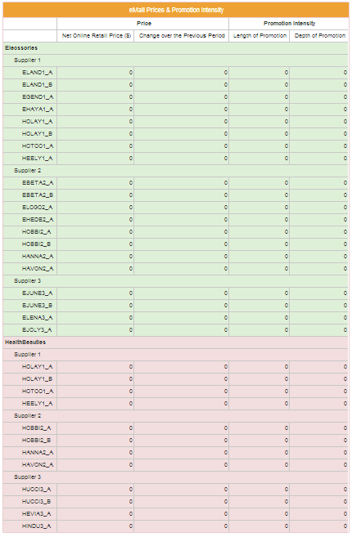

Confidential Reports:

For Suppliers:

1. Financial Results
2. Consolidated Profit and Loss Statement

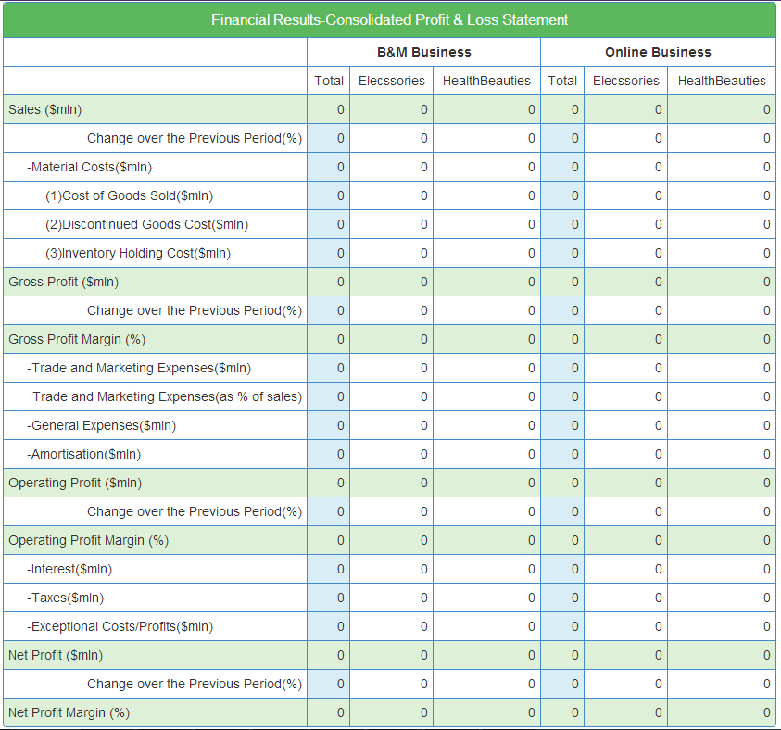

1. B&M Business Profit and Loss Statement

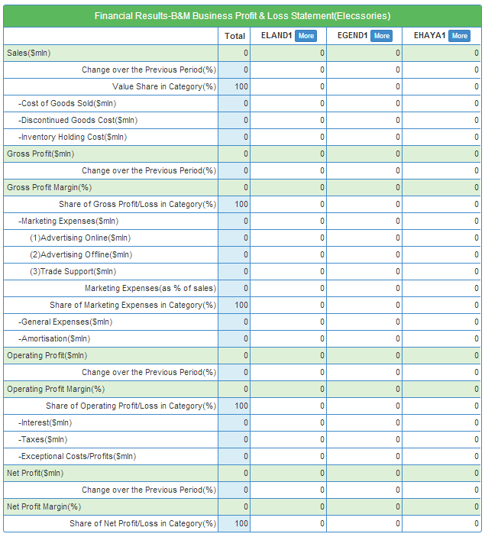

1. Online Business Profit & Loss

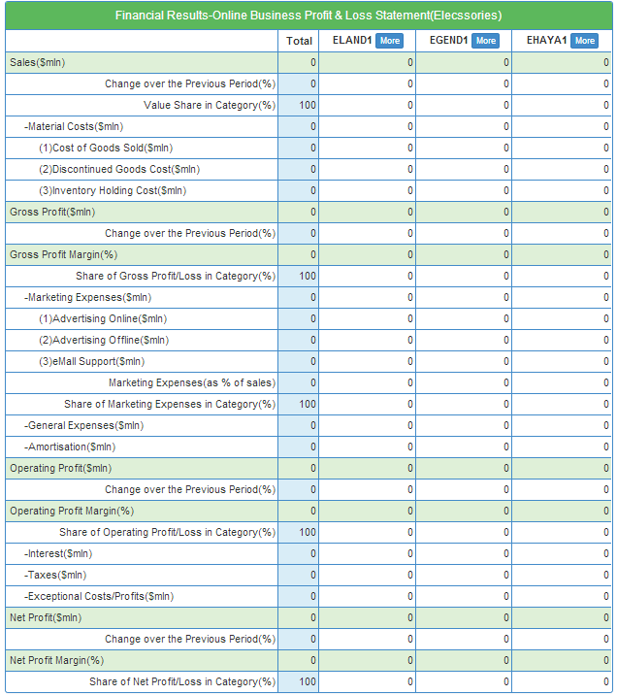

1. Profitability by Channel

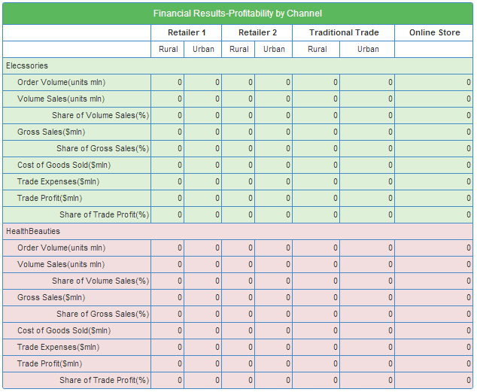

1. Last Period Negotiations

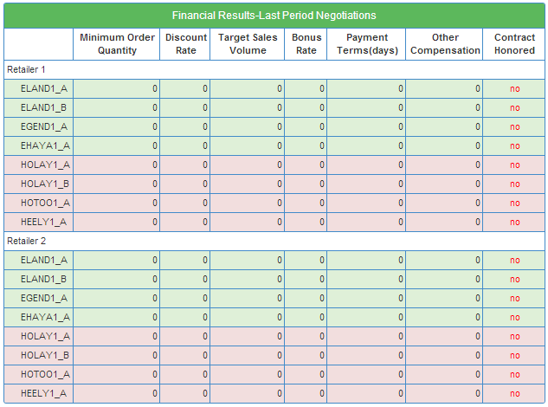

1. Elecssories Situation Report
2. Market Shares by Consumer Segment

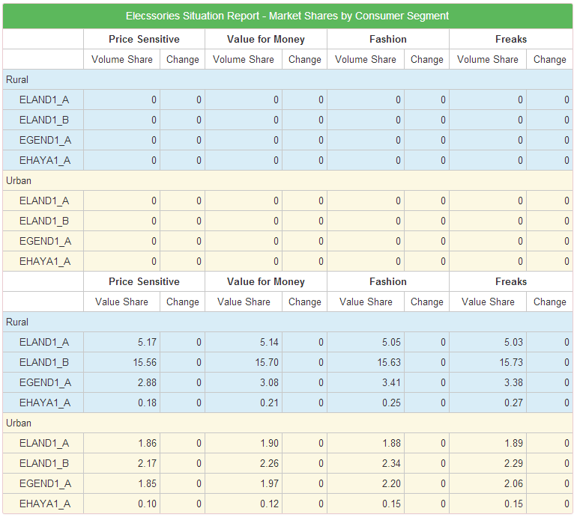

1. Market Shares by Shopper Segment

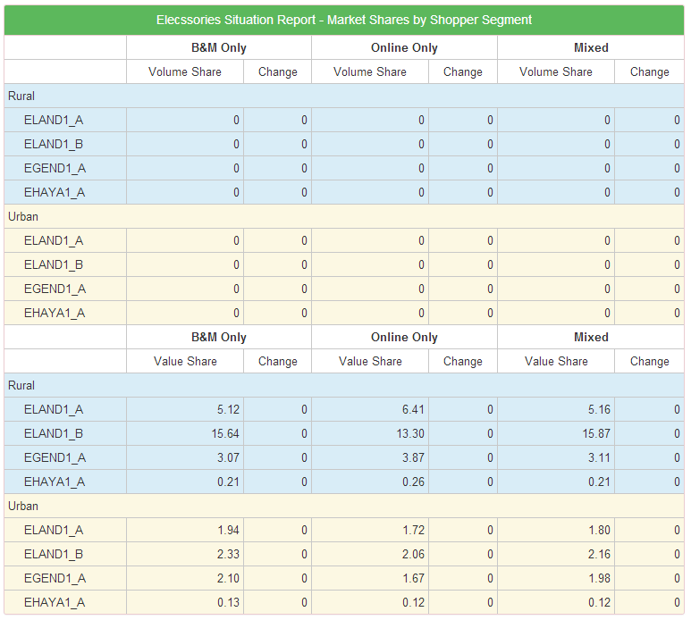

1. Volume

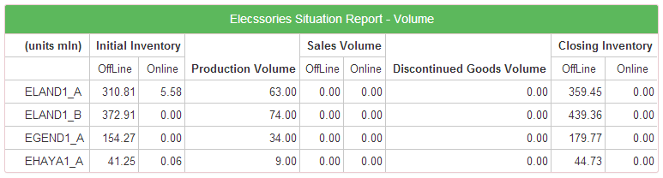

1. HealthBeauties Situation Report
2. Market Shares by Consumer Segment

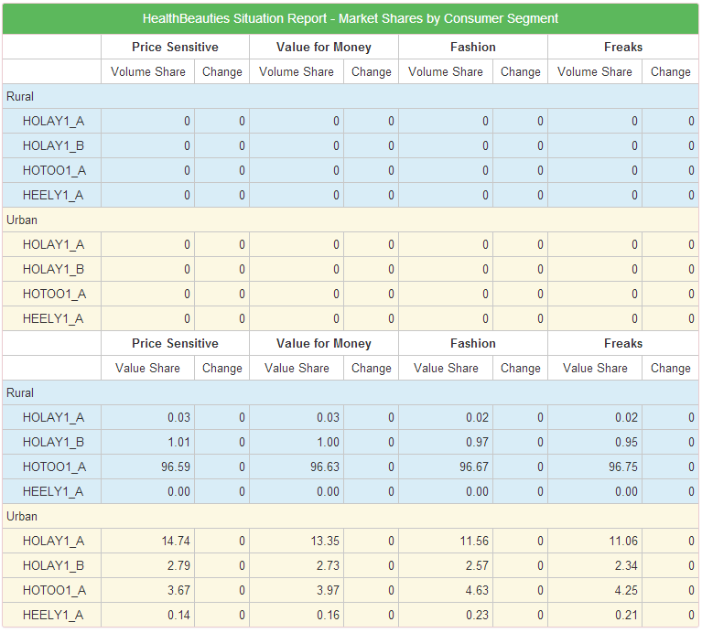

1. Market Shares by Shopper Segment

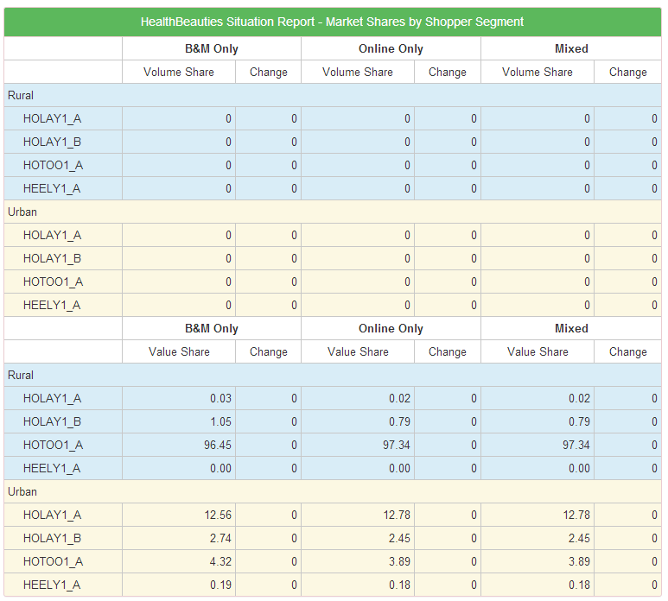

1. Volume

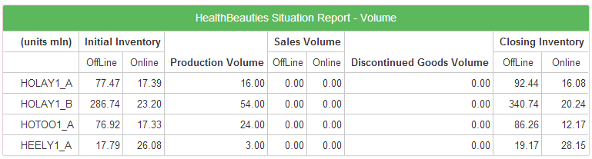

1. Key Performance Indicators

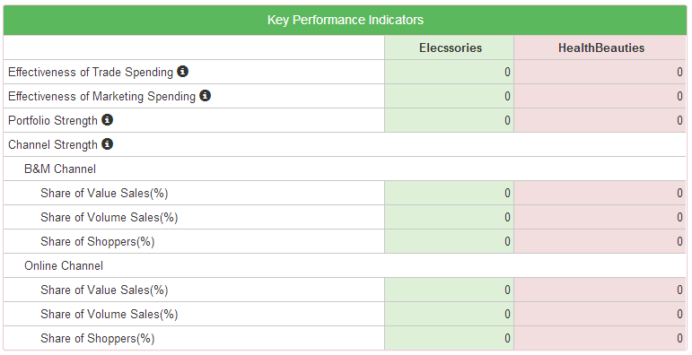

For Retailers:

1. Financial Results
2. Consolidated Profit and Loss Statement

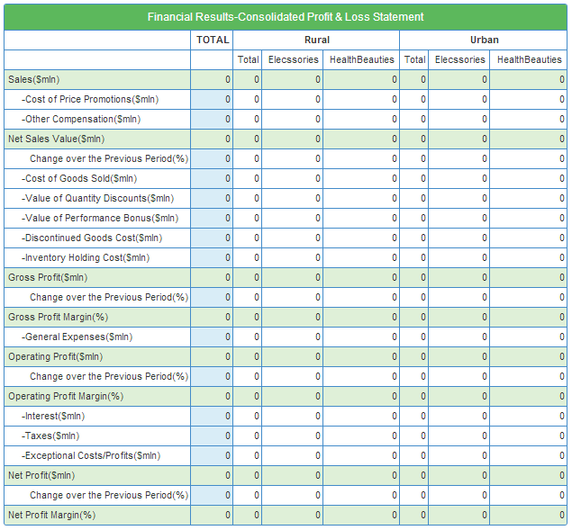

(ii) Rural Profit and Loss Statement

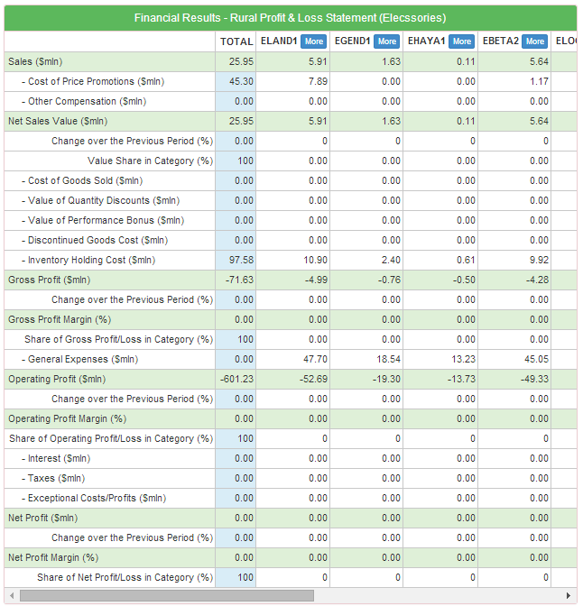

(iii) Urban Profit and Loss Statement

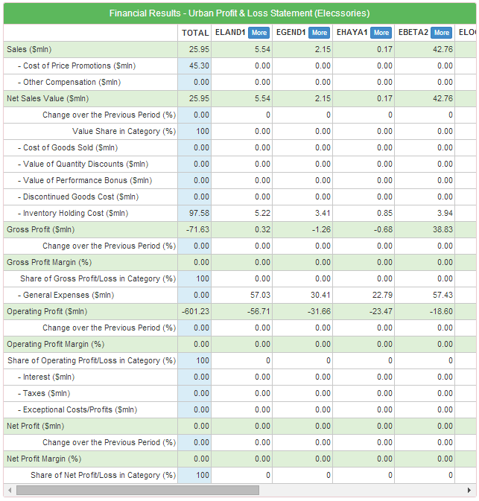

(iv) Profitability by Channel

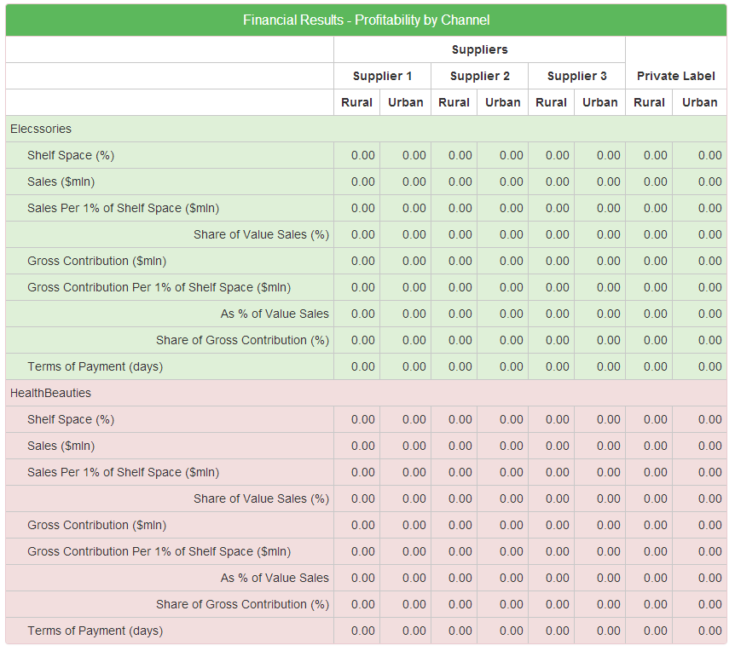

1. Last Period Negotiations

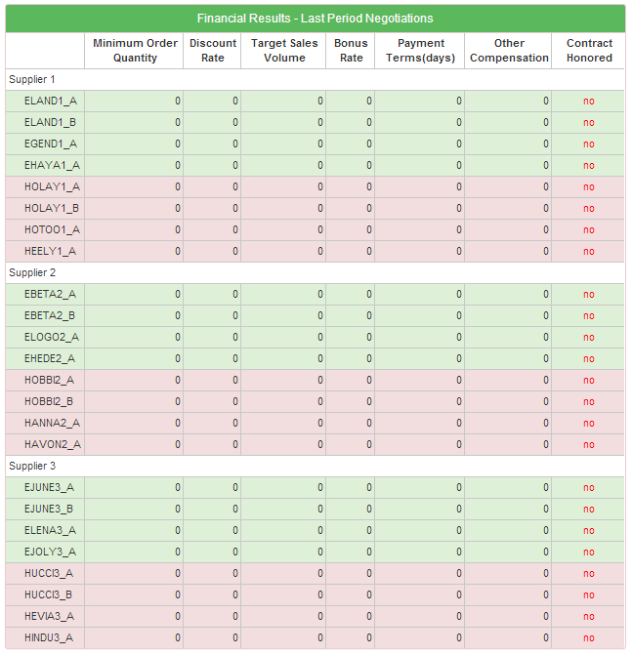

1. Rural Situation Report
2. Market Shares by Consumer Segment

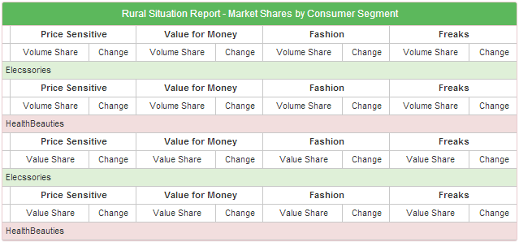

1. Market Shares by Shopper Segment

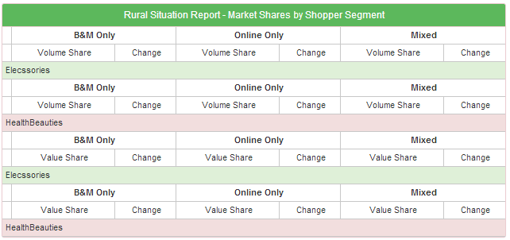

1. Volume

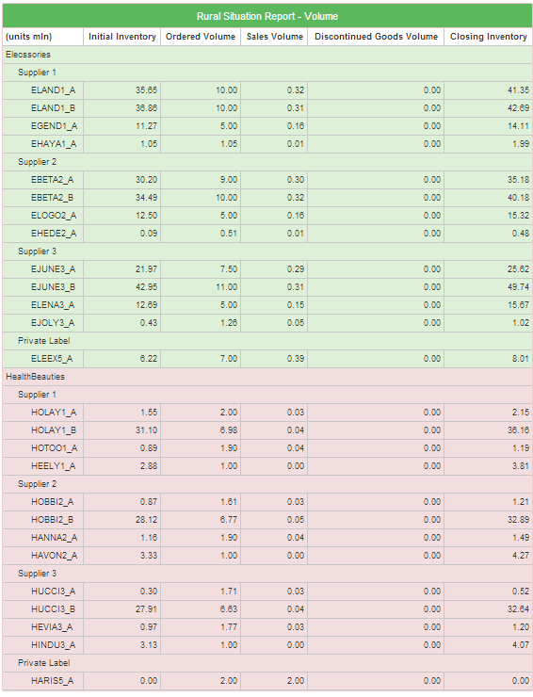

1. Urban Situation Report
2. Market Shares by Consumer Segment

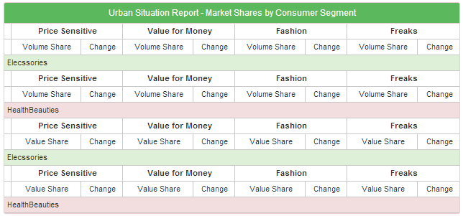

1. Market Shares by Shopper Segment

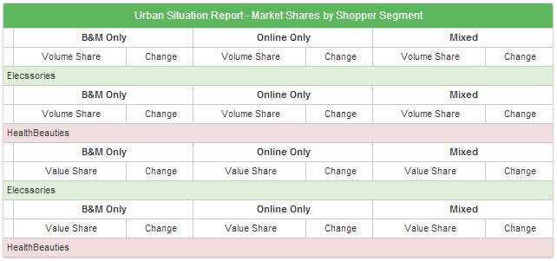

1. Volume

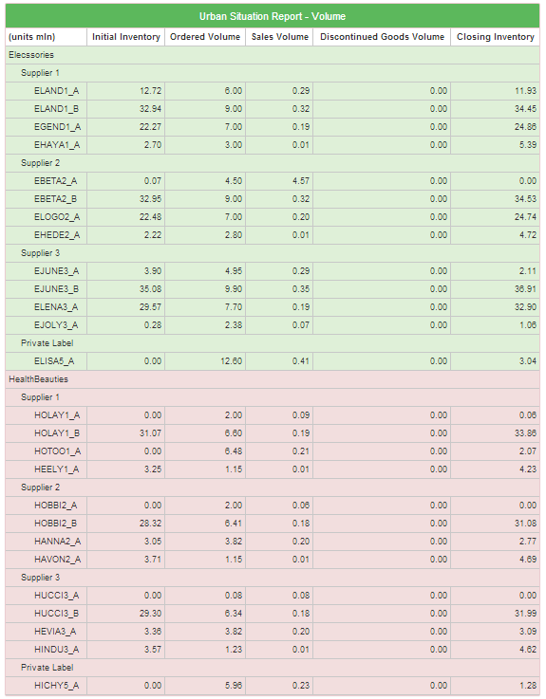

1. Key Performance Indicators

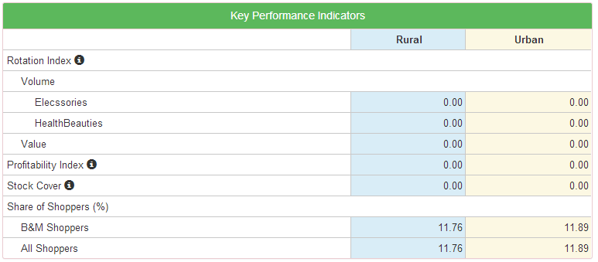

Market Research Reports:

1. Awareness

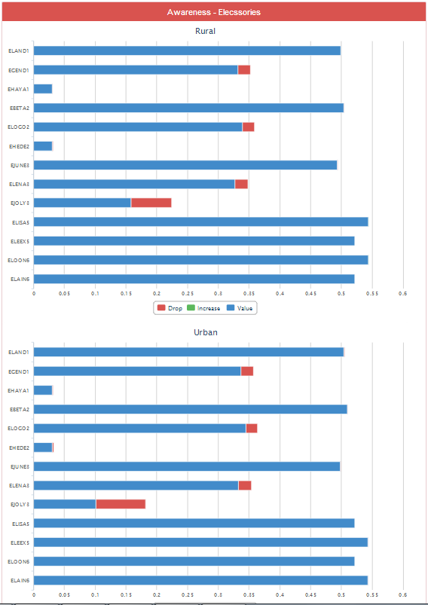

1. Brand Perceptions

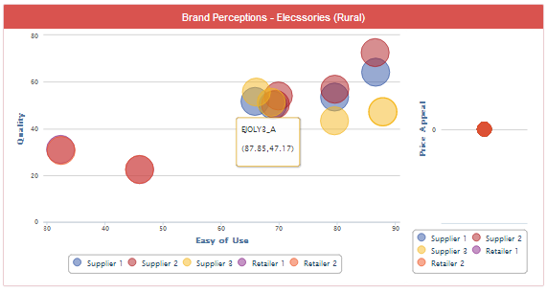

1. Retailer Perceptions

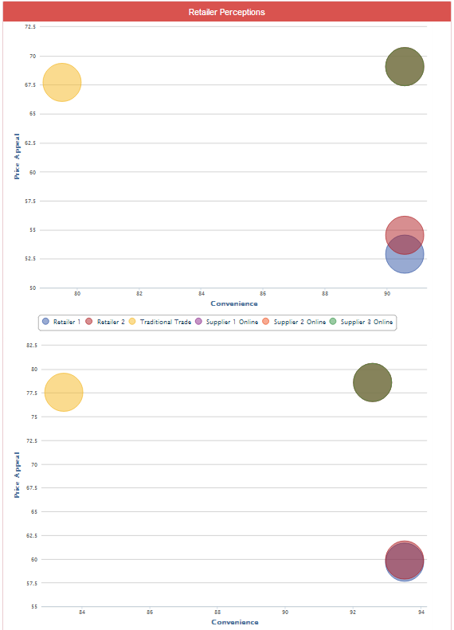

1. Market Shares by Consumer Segment

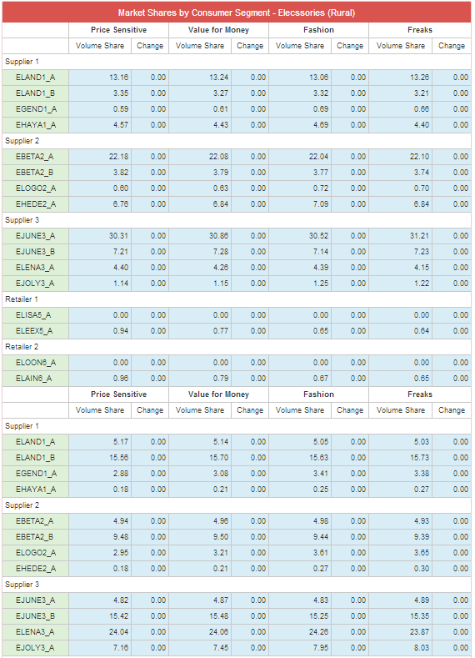

1. Sales by Consumer Segment

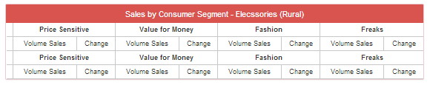

1. Market Shares by Shopper Segment

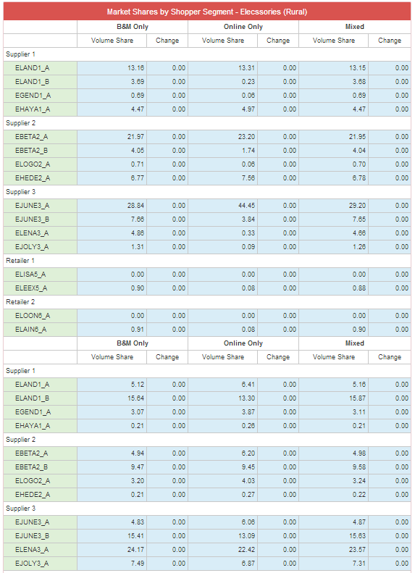

1. Sales by Shopper Segment

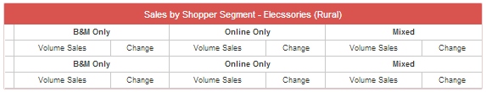

1. B&M Retail Prices

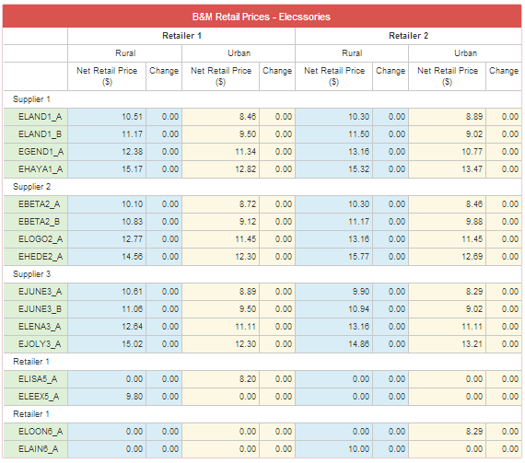

1. Promotion Intensity

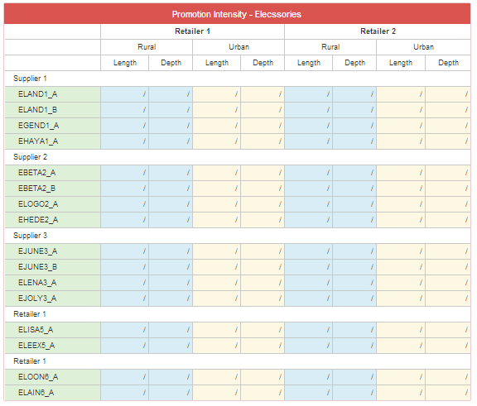

1. Supplier Intelligence

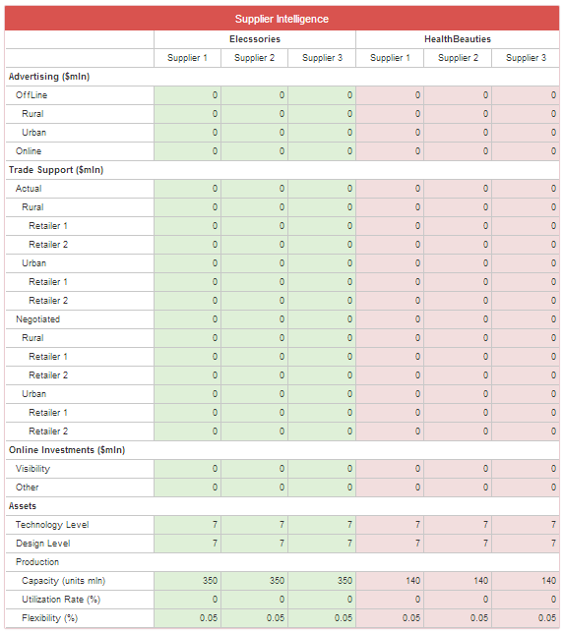

1. Retailer Intelligence

